**Ye, Zhengkun**

**EECS 2500**

**Project 2**

**Ye.zhengkun@rockets.utoledo.edu**

**10/10/14**

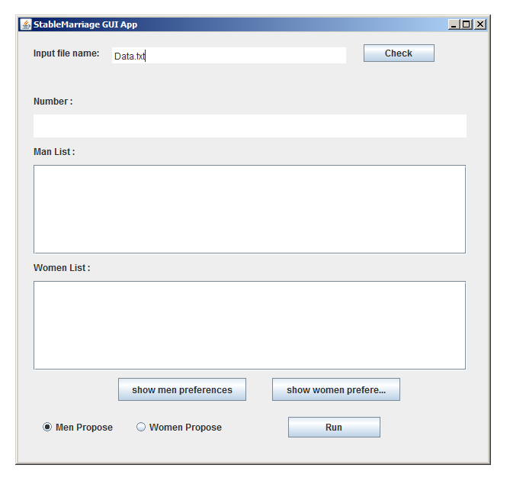

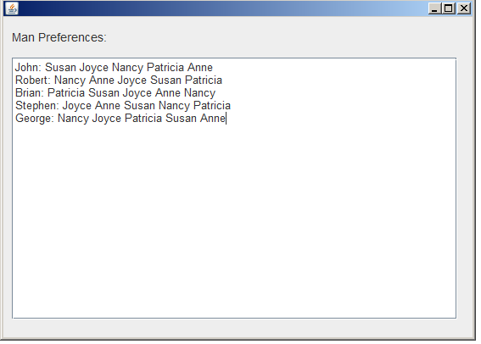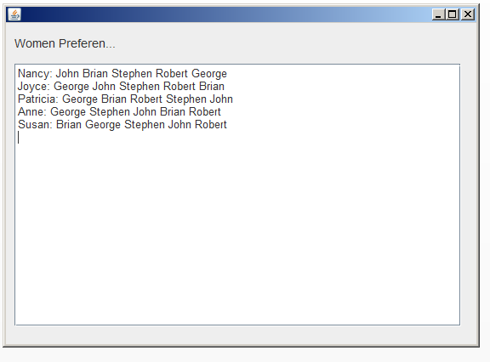

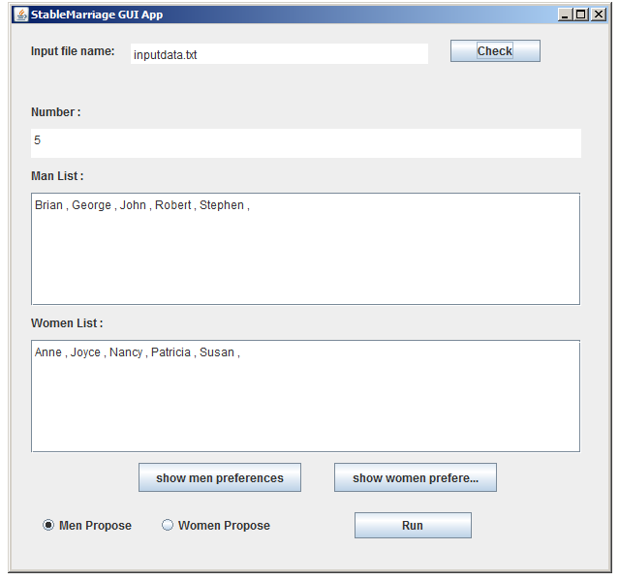

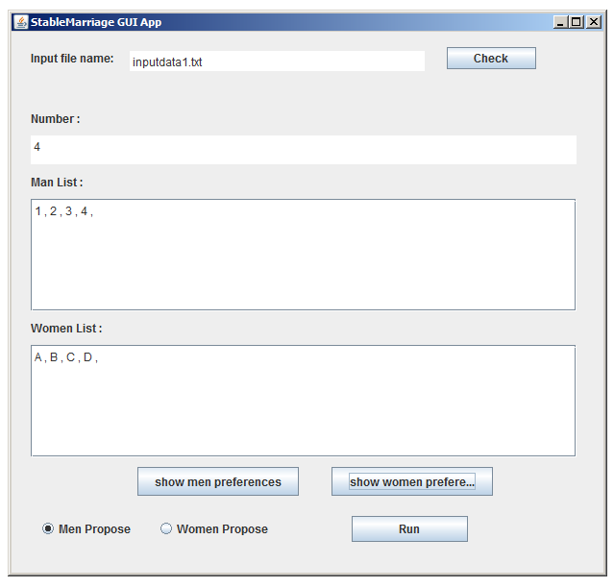

5: Brian George John Robert Stephen

Anne Joyce Nancy Patricia Susan

// Preferences Men:

John: Susan Joyce Nancy Patricia Anne

Robert: Nancy Anne Joyce Susan Patricia

Brian: Patricia Susan Joyce Anne Nancy

Stephen: Joyce Anne Susan Nancy Patricia

George: Nancy Joyce Patricia Susan Anne

// Preferences Women:

Nancy: John Brian Stephen Robert George

Joyce: George John Stephen Robert Brian

Patricia: George Brian Robert Stephen John

Anne: George Stephen John Brian Robert

Susan: Brian George Stephen John Robert

4

1 2 3 4

A B C D

// Preferences Men:

1: B A D C

2: A B C D

3: B C A D

4: A D B C

// Preferences Women:

A: 1 2 3 4

B: 2 1 4 3

C: 3 2 4 1

D: 4 2 3 1

